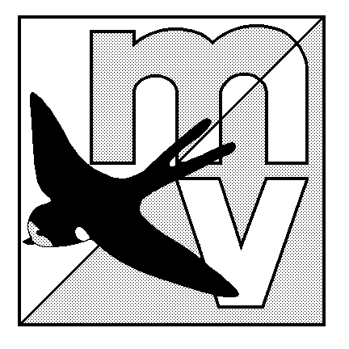MOLE VALLEY ORIENTEERING CLUB
(Affiliated to the British Orienteering Federation)

LIMITED DISTRICT EVENT

The Nower, Dorking
Monday 29th May 2006
(in conjunction with The 29th Surrey Hill Races)

Venue: Small but interesting area of mostly runnable woodland, with many paths. All facilities are close together, and there is an ideal grassy area to have a picnic on after your run (weather permitting!)

Car Park: The Priory School, Dorking, Surrey. OS Map 187, at GR 158488. Follow the ‘Hill Race’ signs from South end of Dorking one-way system. Please share transport where possible.

Map: 1:5000, 5m contours

Registration: 10.00am - 12.00pm Entry on the day only.

Starts: 10.30am - 12.30pm Courses close 2.30pm

Courses: Yellow, Orange and Green only.
The event will be using SportIdent electronic punching (hire charge £1).

Fees: Seniors £4.00 Juniors £1.50

Facilities: Squash, toilets. Dogs welcome.

Officials: Organiser - Neil Lewer (07738 283237)
Planner - Simon Ling

MV Website: http://www.mvoc.org/

Safety: Whistles recommended.

IN THE INTEREST OF SAFETY ALL COMPETITORS MUST REPORT TO DOWNLOAD
Competitors participate in this event at their own risk

